ACS-1809-005
Website Design and Development
“The J&H Computer Booke Shoppe”

Project Group 8

Student Name: John Buksowicz
Student # : 3120391

Student Name: Karanvir Singh
Student # : 3150957

Student Name: Bradley Meso
Student # : 3150339

Date: Monday, June 27, 2022

Introduction
This report presents a potential proposal for a website design for a small side business that sells IT related books, as well as a commentary on said website and design process. Much of the report will be written in way that would emulate a real design proposal; the document will speak as if the website is real, and the writers are role-playing as web-designers. The final two sections will comment on the process and procedure of the website design.
The Organization
The client, J&H Computer Booke Shoppe, is a small, side business of two brothers, John and Henry. The Brothers are experienced software developers and project managers, and have established themselves in the field. Throughout their careers, they noticed a dire lack of accessibility in various texts they needed for their work. Their efforts to successfully navigate this informational sand trap attracted attention, and their colleagues convinced them to start a business to rectify this disturbance in the Manitoba IT industry. In short, they started to sell hard-to-find or desirable and relevant books to IT professionals in Manitoba. In order to expand and seamlessly scale the business beyond their immediate circle of colleagues, a website was necessary.

As noted previously, research indicates that J&H fulfills a particular market need: providing high quality, sought after, hard-to-find, specialized texts for IT professionals. The clients opine that the first-response of such a customer is to head to a local bookstore. Visiting Bison Books, in Downtown Winnipeg, (424 Graham Avenue), whose tagline is “Old, Rare and Out-of-Print Books Bought and Sold” has a dearth of IT related books. The scant IT tomes they do have are all for the very beginner. The same holds true when visiting a Coles, or the Chapters website. A potential customer, which was once our clients, have their first guess be a dud. The next is to go on amazon.ca. Going there yields a page filled with workout equipment, women’s clothing, action movies and other knick-knacks. One has to locate the tiny “books” button on the navigation bar, then scroll down to find a “Computers and Technology” subsection and then dig through dozens of pages of beginner texts to find a copy of something one might be looking for – and then notice it costs two hundred dollars and ships from Australia. Not ideal. The final stop a customer would make is going directly to a publishers website. This presupposes that the customer knows precisely which text they want, as well as the bibliographical details of such a text. Then, the book must be in stock.
What if this entire process was streamlined and abstracted away into one location, and a couple of clicks? What if the customer did not need to be a reference librarian in order to find what they’re looking for? This is precisely where J&H Computer Booke Shoppe’s website can come in. The website would connect the customers to the IT-info-retrieval experts, John and Henry. Better yet, preempt the search with human-generated suggestions, flow-charts, reading pathways and a way to efficiently contact these experts. This is how the website must serve this organization.

Plan
Defining Goals:
The current focus of the business is to sell books to local IT professionals in Manitoba. This includes stocking commonly desired books, as well as having the ability to recommend alternative titles. Selling books includes arranging for pick up or shipping to the customer.
Target Audience:
The bulk of the target audience can be broadly classified as IT Professionals. This audience would not be necessarily interested in beginner or novice level texts in IT topics. Books on a more specific areas of Computer Science, Programming, System Administration and other areas would be more relevant to this group. Computer Scientists could want paper copies of CS journals or books on certain mathematical techniques or algorithmic analysis. Programmers would be interested in particular implementations of certain software packages or frameworks. System administrators might need to learn a new technology or strategies for managing larger and more complex networks, and so on. Let's call this group audience 1A.
However, this audience would also appreciate "classic" texts. These texts, such as Structure and Interpretation of Computer Programs by Abelson and Sussman, or Compilers: Principles, Techniques, and Tools are well known and well regarded even after decades after their publication — quite a feat in a fast moving field such as IT! In fact these books often have nicknames; in the previous two examples "the Wizard book" and "the Dragon book" respectively. Given their status in the larger IT community, any member of this audience segment would want to have these titles in their libraries and on their coffee tables. It would be imperative to not only have them in stock but to include and capture these status elements into the design and theme of the website build the brand. Let's call this sub-audience Audience 1B.
Another portion of this audience are interested in technical documents: manuals, specifications, instructions, diagrams, pin-outs, PCB designs and so on. This segment of IT professionals are laser focused on what they are looking for, and need to be served separately. The converse is also true: these items must not clutter what the other audience segments see. Let's call this subgroup Audience 1C.
While not initially a priority audience, a look at IT-related book sales data reveals that beginner and novice books do in fact sell. Furthermore, established IT professionals in one field might want to branch out into another field. A small section of the site catered towards these introductory texts would serve this hybrid audience. Let's call this subaudience 2A.
Finally, as a local institution, the initial target audience are all Manitobans. Emerging technologies unique to or at least relevant to Manitoba's IT Sector should receive a special emphasis. Community building and personal networking would further serve this audience segment. This subaudience shall be labeled 2B.
These disparate audience groupings would require different levels of service from the website. The lowest level of service can be called the M.I.B.O model – Money In, Books Out. These customers would simply browse, shop and buy books that might interest them. In order to serve this audience segment, the website must have a wide range of books on display; no category or product type can be more that three clicks away from a home page. All major categories need to be hit. Ledgeview Partners, a member of FORVIS, a top 10 professional services firm from the United States, writes that “34% of consumers are more likely to make an unplanned purchase after receiving personalized content.”
A medium level of service are those who may need more information or additional assistance compared with the low level service group. This group is a great target for the “Request-a-Title” feature, which will be explained below. These customers need recommendations, or have general inquiries and are after types of books rather than specific titles.
A high level of service means that the customer either wants to build a library, a curriculum, or is looking for a particular rare and obscure text. Having exhausted all other options, they need a professional with experience to guide them to what they need. Recall that this very idea is the raison d’etre of the business itself. The direct application of John and Henry’s expertise needs to be clearly indicated and made available on the website.
The table below briefly summarizes some facts about the websites audience.
Audience Type | Label | Age | Occupation | Service Level
Programmer – Work-Based Learning | 1A | 25-55 | Mid-level IT professional | Low to medium – can generally self serve but may need specific recommendations or general questions.
Programmer – new skill/ library building | 1B | 35-55 | Higher level, experienced IT pro | Medium to high – is more interested in recommendations or more obscure texts.
Computer/Electical Engineer | 1C | 25-55 | Computer/Electrical engineer | High – laser focused on what they want, and they want it fast.
Beginner | 2A | 18-30 | Either a novice or an IT pro undergoing retraining | Medium – will be satisfied with a good selection of beginner or intermediate texts
Local-specific | 2B | 25-55 | IT pro in a Manitoba specific industry | Variable – general category

Intended Benefits
The benefits the website would bring over other competitors in the market are:

1) Specificity - General Book retailers, whether brick and mortar or large online e-retailers, are heavily weighted toward beginner and novice texts and general introductions to concepts, once the customer has already expended effort searching and paring down options. This website more specifically caters towards IT professionals in product selection, curation, and design. Where the design of a website like Chapters or Amazon have search functionality and categories for all topics, and lump IT into one monolithic category, our website would be geared toward serving our audience's specific interests.
2) Curation - Because of our specialization and knowledge of the field, we are able to curate. This means we can present alternative titles to out of print texts, suggest reading paths and more effectively advertise niche books to people in that particular niche.

Primary Intent
To reiterate: the ultimate point of the website's existence is to sell books, particularly rare and niche, to IT professionals.

Competitor websites

1) Amazon — this general retailer sells many books from all over the world. Our edge over the giant is our ability to curate and greater user ability to search and discover relevant books. For example, the front page of amazon.ca has shoes, movies and pet toys on the front page. We'd have what the customer wants or a clear path to find what he wants on our front page. As a local business, direct human contact and the ability to respond to requests rapidly also gives us an advantage.
2) Chapters, Coles etc — these websites are more specific than Amazon, and have physical brick and mortar stores in Manitoba, but still suffer from the same generality as Amazon. Again, Chapters has romance novels, pop music CDs and pillows on the front page.
3) NoStarch press — this San Francisco based publisher focuses on Computer Science books. While the website does have a selection of intermediate or advanced texts as well as what is described as "geek entertainment" it lacks the more professional oriented texts identified in Audience 1C. Also, this website does not have any Manitoba connection, and only sells book from a specific publisher. While the website has interesting features, such as TOCs for each book, a "You might like..." section, and reviews, it does not have a more personalized method of curation, or the ability to place custom orders, ask for support and so on. nostarch.com is their website.
Site Structure
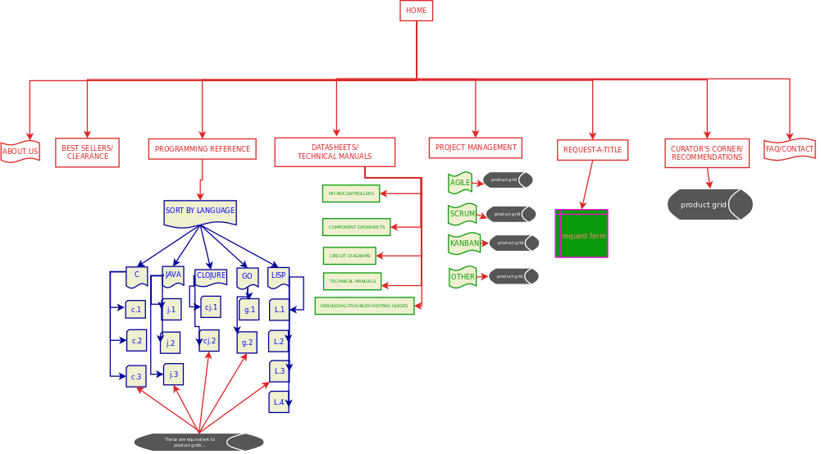
The navigation of the site needs to quickly filter into the most relevant topics of books to sell. Therefore, the site’s homepage links to the major product categories: programming, hardware, and project management. The homepage also links to the sites main features: Request-a-Title and recommendations/curations. The homepage also links to various informational pages: an About Us page, a F.A.Q. page, location page and so on.
The product pages link to internal anchors for each specific subgenre or topic area. For example, a Table of Contents on the Programming page lists links to each programming language represented.

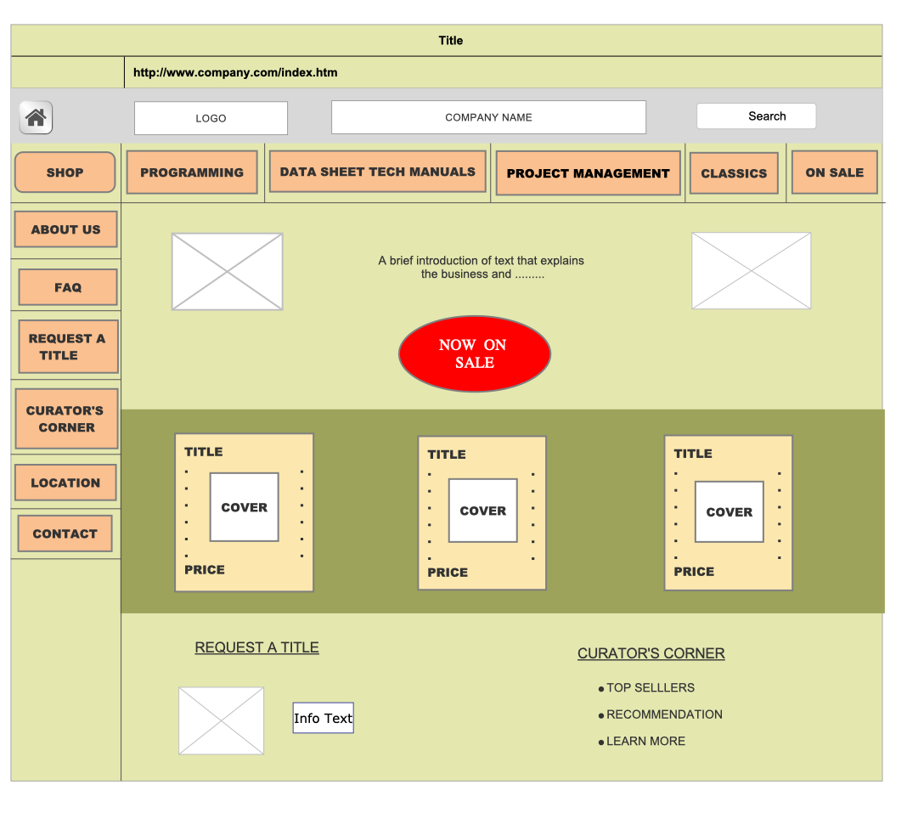
Above is a mock up of what the homepage might look like. Note that the previously mentioned product categories are immediately visible in the top horizontal navigation bar. One click takes the user to their desired category of choice immediately. The side panel lists links to important information and site features. The main content of the page is brief descriptions of features to funnel the user to the store pages as quickly as possible, a sample of eye catching texts at discount prices, as well as recommendation and curation resources. No waste.
One of the clients requirements was a way to liquidate old stock. The clear way to do this is through sales. These sales are prominently displayed, and sale titles get their own section on the site.
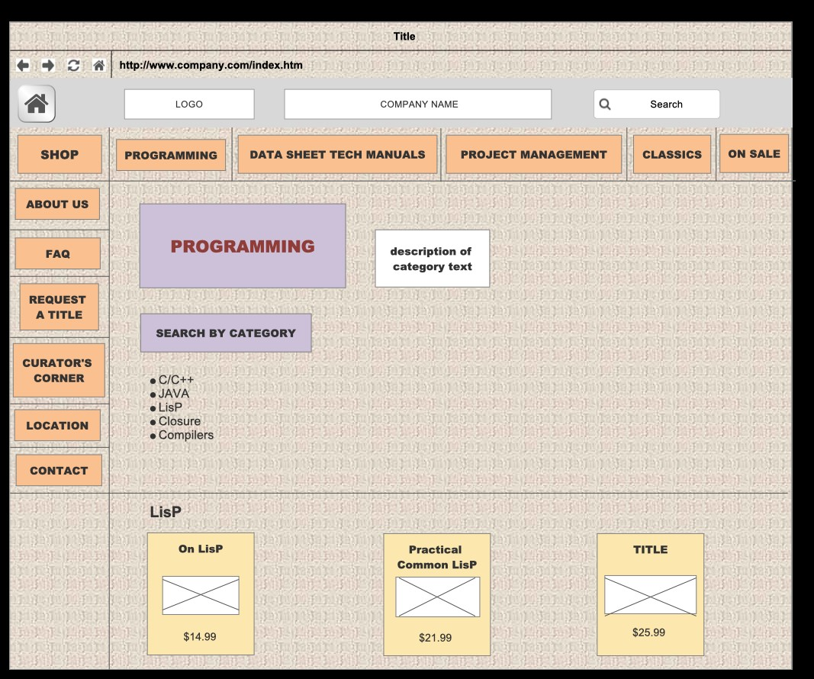
The above figure is an example category page. A quick subtopic directory links to internal anchors within the page that send the user past the irrelevant titles to the relevant ones. Note the “Back to Top button for more convenient navigation.
One advantage of selling to computer proffessionals is that we can expect them to be web-browsing power users. They are likely to use advanced browser search tools, for example the “swiper” package in the Common Lisp based nyxt browser.

Project Experience
A general overview of the project’s progression can be determined by the commit frequency of our project’s github page:
- Week of May 22 – 12 commits
- Week of June 2 – 2 commits
- Week of June 12 – 4 commits
- Week of June 19 – 17 commits
- Week of June 26 – 2 commits
The first phase of the project was planning. Based on the five step plan in the textbook, we discussed the plans for the website, sought to understand the business and the business’ position in the market, and basic layout design ideas. This is where most of the site map and directory structure of the website came to be.
The next phase was beginning to more specifically plan the website layout and begin writing it. This corresponded to covering Chapters 5 and 6 in class, that is to say beginning to learn about implementing site layouts through CSS floats and positioning. Supplementing the lectures, we looked at Learning Web Design: A Beginner's Guide to HTML, CSS, JavaScript, and Web Graphics by Jessica Niederst Robbins and HTML and CSS: Build and Design Websites by John Duckett. The book by Robbins had a particularly helpful chapter that really explained document flow with respect to floating. We were having problems with our aside and main divisions interfering with each other. Unfortunately, these books teased Flexbox and Grid, which our original designs might have been better served by.
The third phase was to take our researched book lists, and fit them into templated platforms to be inserted into the various product category pages. This was incredibly tedious work once the base product template was created using table structures. Another bit of taedium was resizing images and placing them into the proper directories while making sure all titles matched. After some changes due to both content research and a lack of time, some pages had to be cancelled or reworked. This meant that the links to these pages had to be changed in every document we had written this far. We will further comment on this in the conclusion.
The final stage was cleaning up the pages, writing up the report and preparing for submission.
The most clever feature of the website is the Request-a-Title feature. Looking at other websites that sell books or products in general, most of the design flows from two sources. Firstly, graphic design: catchy graphics and animations, large, sprawling displays of products, models posing and so on. Secondly, various scripting: advanced searches, endlessly scrolling bars of products, generated recommendations, the list goes on. These are outside the scope of the course and our abilities. In order to emulate these features, and provide a more engaging website, we strung together simple HTML form elements in a way to create a more interactive and dialogue based system, where the user is inputting their desires in almost conversational or interview way. This simple trick using mundane tools punches above its weight.
A major struggle we had during the project, and the one thing we would need to improve the most is the selection of books. Despite talking about the need for advanced or rare books, many of our books are in fact beginner books. However, we ourselves are beginners, and do not have intimate knowledge with IT. Many of the text descriptions we saw might as well be in Greek. While I’m sure we will shortly encounter LALR parser grammers in Backus-Naur Form, we couldn’t confidently display such information on our website. At the end of the day, to hold a meta-perspective, the book entries are really glorified lorem ipsums and demonstrations of our knowledge of HTML and CSS instead of deep marketing data.
Conclusion
Many valuable and unexpected insights were gained in the creation of this project. I believe none of us will look at a website the same way again. Some of us have gotten in the habit of inspect element-ing or View Page Source-ing interesting web pages we come across. While many of the cool tricks we’ve come across couldn’t make it into our website, the realization that it is infact “that simple” to do very interesting visual effects. One effect we implemented had its genesis in a silly exercise from the Robbins text. The exercise had the student fool around with border-radius values. We thought we could reign in this technique and give our buttons on oblique look by having two different x and y border radii.

As Computer Science students, we’d like to approach some of the difficulties we more programmatically. One major source of annoyance was managing differences in templates across different pages in different states of completion. We used git version control software in a very naive way, merely as a back up and distribution method and did not exploit its more collaboratorial features. Secondly, much of the pages are template-like in structure: all product tables are the same in structure, only the data in them changes. The navigation elements are uniform across all pages. We had some initial ideas on generating this content through knowledge gained in ACS-1904: using JavaDB to store product data, and writing the strings into the file, using integer offsets to position each field. This would have been extremely tedious to write and maintain. We are burning for the know-how on generating HTML pages programatically. We hope such ideas are included in the upcoming Internet Programming Course.

At the end of the semester, we do in fact have a working website for an online IT book store – something we would not have been able to do eight short weeks ago. We would like to close with sincere gratitude to Professor Pak for his instruction and guidance.

References
- most product descriptions were inspired from marketing blurbs found on the amazon.ca best sellers in Computers and Technology listings.
- Many of the classic texts were found in “Raymond, Eric S. The New Hacker's Dictionary. 3rd ed., MIT Press, 1996.”
- Web sight statistic numbers come from https://ledgeviewpartners.com/blog/web-traffic-statistics-you-should-know-in-2020/ a website for Ledgeview Partners, a business and technology consulting company.
- Duckett, Jon. HTML and CSS: Design and Build Websites. 1 ed., Wiley, 2011.
- Robbins, Jennifer N. Learning Web Design: A Beginner's Guide to HTML, CSS, JavaScript, and Web Graphics. 4th ed., O'Reilly Media, 2012.
- Bison Books, 424 Graham Ave, Winnipeg, MB R3C 0L8

